**Twelve Angry Men**

**About the author:**

**Sidney Arthur Lumet** (June 25, 1924 – April 9, 2011) was an American director, producer, and screenwriter with over 50 films to his credit. He was nominated five times for the Academy Award: four for Best Director for *12 Angry Men* (1957), *Dog Day Afternoon* (1975), *Network* (1976), and *The Verdict* (1982) and one for Best Adapted Screenplay for *Prince of the City* (1981). He did not win an individual Academy Award, but did receive an Academy Honorary Award, and 14 of his films were nominated for Oscars, including *Network*, which was nominated for ten and won four.

**About the film:**

*12 Angry Men* is a 1957 American courtroom drama film directed by Sidney Lumet, adapted from a 1954 teleplay of the same name by Reginald Rose. This courtroom drama tells the story of a jury of 12 men as they deliberate the conviction or acquittal of an 18-year old defendant on the basis of reasonable doubt, forcing the jurors to question their morals and values.

*12 Angry Men* explores many techniques of consensus-building and the difficulties encountered in the process among this group of men whose range of personalities adds to the intensity and conflict. It also explores the power one person has to elicit change. The jury members are identified only by number; no names are revealed until an exchange of dialogue at the very end. The film forces the characters and audience to evaluate their own self-image through observing the personality, experiences, and actions of the jurors. The film is also notable for its almost exclusive use of one set, where all but three minutes of the film takes place.

In 2007, the film was selected for the National Film Registry by the Library of Congress as being "culturally, historically, or aesthetically significant". The film was selected as the second-best courtroom drama ever (after To Kill a Mockingbird) by the American Film Institute for their AFI's[1] 10 Top 10 list.

**Brief Summary:**

"12 Angry Men" focuses on a jury's deliberations in a capital murder case. A 12-man jury is sent to begin deliberations in the first-degree murder trial of an 18-year old Puerto Rican boy accused in the stabbing death of his father, where a guilty verdict means an automatic death sentence. The case appears to be open-and-shut: The defendant has a weak alibi; a knife he claimed to have lost is found at the murder scene; and several witnesses either heard screaming, saw the killing or the boy fleeing the scene. Eleven of the jurors immediately vote guilty; only Juror No. 8 (Mr. Davis) casts a not guilty vote. At first Mr. Davis bases his vote more so for the sake of discussion; after all, the jurors must believe beyond a reasonable doubt that the defendant is guilty. As the deliberations unfold, the story quickly becomes a study of the jurors' complex personalities (which range from wise, bright and empathetic to arrogant, prejudiced and merciless), preconceptions, backgrounds and interactions. That provides the backdrop to Mr. Davis' attempts in convincing the other jurors that a "not guilty" verdict might be appropriate. And slowly, little by little, by proving that the proof brought by the accusers was proven wrong by physical facts such as old age or bad eyesight. In the end the boy is considered as not guilty.

**Main Characters:**

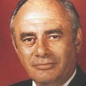 Juror 1 played by: Martin Balsam

 Juror 2 played by: John Fiedler

 Juror 3 played by: Lee J. Cobb

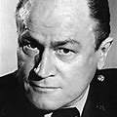 Juror 4 played by: E.G. Marshall

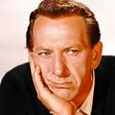 Juror 5 played by: Jack Klugman

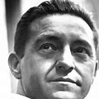 Juror 6 played by: Edward Binns

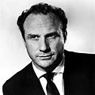 Juror 7 played by: Jack Warden

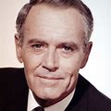 Juror 8 played by: Henry Fonda

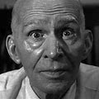 Juror 9 played by: Joseph Sweeney

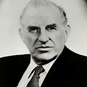 Juror 10 played by: Ed Begley

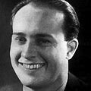 Juror 11 played by: George Voskovec

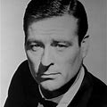 Juror 12 played by: Robert Webber

**My feelings (Impressions):**

I found the film Twelve angry men, very well done and interesting. The way the fact of the trial are apprehended are interesting, the reconstitution of the events that would of occurred and how the Witnesses had reported them. The women across the street saying that she sore the boy killing his father while she was trying to go to sleep in her bed without her glasses or an old man having said he herd the body fall to the ground and having succeeded despite his old age and his limping leg to get to the door and open it just in time to see the boy dashing down the stairs.

1. American Film Institute